METTA CORPORATE | SECTION: Resident Care
REGULATION: RHA 15 | POLICY NAME: Zero Tolerance of Abuse and Neglect
POLICY NO: | Metta Lifestyles Retirement | EFFECTIVE DATE: Jan 2019
 | REVIEWED DATE: August 2020 | Reviewed: September 2020

COVID-19 Visitor Policy

Note: The changes highlighted in this policy take effect September 15, 2020.

Policy:
As of June 18th, 2020, Metta Lifestyles began a careful, phased approach to the gradual resumption of resident visits during the COVID-19 pandemic, ensuring residents receive visitors safely to help protect against the risk of COVID-19. All visitors will be instructed to adhere to the requirements set out in this policy to ensure the health and safety of all residents, staff and visitors, and allow for the continuity of visits that support the mental, physical and spiritual needs of residents for their quality of life while also supporting residents in receiving the care they need and maintaining their emotional well-being.

This policy complies with current ministry requirements per Directive #3 (August 28, 2020) and aligns with the Ministry for Seniors and Accessibility (MSAA) Reopening Retirement Homes guidelines (September 8, 2020). The rules in the policy are in addition to the requirements established in the Retirement Homes Act, 2010 and its regulation (O. Reg 166/11). Any non-adherence to the rules set out in the visitor policy could be the basis for discontinuation of visits.

Informed by the ongoing COVID-19 situation in the community and the residence, the residence’s visitor policy will be reassessed and revised to allow for increased or decreased restrictions as necessary, as circumstances change in the community, within the residence and with new directives.

Guiding Principles
There is an ongoing need to protect retirement home residents and staff from the risk of COVID-19, particularly as some residents are more susceptible to more severe effects of COVID-19 than the general population.
This visitor policy is guided by the following principles:
Safety: Any approach to visiting in the residence must balance the health and safety needs of residents, staff, and visitors, and ensure risks are mitigated.
Emotional Well-being: Allowing visitors is intended to support the emotional wellbeing of residents by reducing any potential negative impacts related to social isolation.
Equitable Access: All residents must be given equitable access to receive visitors, consistent with their preferences and within reasonable restrictions that safeguard residents.

Flexibility: The physical/infrastructure characteristics of the home, its staffing availability, and the current status of the home with respect to personal protective equipment (PPE) are all variables to take into account when setting home-specific policies.

It is with compassion that we recognize the need for residents’ connection with loved ones, and it is through in-person visits that this can be best achieved. We will take all reasonable steps to help facilitate visits within the parameters of ministry directives. Per ministry guidelines, the residence will follow the requirements for minimum visit frequency and seek to accommodate more visits where possible. Where it is not possible or advisable for visits to occur in person, the residence will continue to provide virtual visiting options.

[Name of Residence] also recognizes the concepts of non-maleficence (i.e. not doing harm), proportionality (i.e., to the level of risk), transparency and reciprocity (i.e., providing resources to those who are disadvantaged by the policy). These concepts will inform the residence’s decision making with regards to the scheduling and/or refusal of visits as appropriate.

Prior to Accepting Visitors
As per Ministry of Health (MOH) Directive #3 and MSAA guidelines, the following baseline requirements must be met prior to accepting visitors:
- The residence must not be in a COVID-19 outbreak.
  - In the event the residence has begun accepting visitors and enters into an outbreak, all non-essential visitations will be discontinued, and the residence will follow all Chief Medical Office of Health (CMOH) directives for residences in outbreak and directions from the local public health unit (PHU). (see note below)

- The residence has developed:
  - Procedures for the resumption of visits and a process for communicating these procedures with residents, families and staff, including but not limited to infection prevention and control (IPAC), scheduling and any setting-specific policies.
    - This process must include sharing an information package with visitors on IPAC, face covering/masking, physical distancing and other operational procedures such as limiting movement around the residence, if applicable, and ensuring visitors’ agreement to comply. Residence materials must include an approach to dealing with non-adherence to residence policies and procedures, including the discontinuation of visits. (See Appendix A)
  - Dedicated areas for both indoor and outdoor visits to support physical distancing between residents and visitors.
  - Protocols to maintain the highest of IPAC standards prior to, during and after visits.
  - A list of visitors available for relevant staff to access.

Note: Residents who are self-isolating for 14 days under Droplet and Contact precautions may not receive visitors. However, the residence may allow residents who are not self-isolating to receive visitors, provided the home is not in outbreak.

Additional factors that will inform decisions about visits in the residence include:
- Adequate Staffing: The home must currently not have staffing shortages that would affect resident or staff safety and not be under a contingency staffing plan. There must be sufficient staff to implement the protocols related to visitors. Additionally, staffing levels must be sufficient to ensure safe visiting as determined by the home’s leadership.
- Access to adequate testing: The residence must have a testing plan in place, based on contingencies and informed by local and provincial health officials, for testing in the event of a suspected outbreak.
- Access to adequate Personal Protective Equipment (PPE): The residence must have adequate supplies of relevant PPE.
- Infection Prevention and Control (IPAC) standards: The residence must have appropriate cleaning and disinfection supplies and adhere to IPAC standards, including enhanced cleaning.
- Physical Distancing: The residence must be able to facilitate visits in a manner aligned with physical distancing protocols.
Types of Visitors
All visitors are responsible for adhering to applicable directives including Directive #3, MSAA guidelines and the home’s visitor policy. Visitors should consider their personal health and susceptibility to the virus in determining whether visiting the residence is appropriate. Outlined below are the three types of visitors.

Note that retirement home staff and volunteers are not considered visitors as their access to the residence is determined by the licensee.

1. Essential Visitor |  | 2. General Visitor | 3. Personal Care Service Provider
A. Support Worker | B. Caregiver
A support worker is a type of essential visitor who is brought into the home when there are gaps in services to perform essential services for the home or for a resident in the home.  Examples of support workers include:  - Regulated health care professionals under the Regulated Health Professions Act, 1991 (e.g., physicians, nurse practitioners);  - Contract workers hired by the home or LHIN care services, including home care providers (e.g., nursing care, physiotherapy, occupational therapy, social workers);  - Maintenance workers;  - Private housekeepers; and  - Food delivery.  Support workers do not include retirement home staff. | A caregiver is a type of essential visitor who is designated by the resident and/or their substitute decision-maker and visits to provide direct care to the resident (e.g., supporting feeding, mobility, personal hygiene, cognitive stimulation, communication, meaningful connection, relational continuity and assistance in decision-making).  A maximum of 2 caregivers may be designated per resident. The designation should be made in writing to the home. Homes should have a procedure for documenting caregiver designations.  A resident and/or their substitute decision-maker may change the designation in response to:  - A change in the resident’s care needs that is reflected in the plan of care; and/or  - A change in the availability of a designated caregiver, either temporary (e.g., illness) or permanent.  Examples of caregivers include family members who provide direct care, a privately hired caregiver, paid companions and translators. | A general visitor is a person who is not an essential visitor and visits:  - To provide non-essential services (may or may not be hired by the home or the resident and/or their substitute decision maker);  - For social reasons (e.g., family members or friends); and/or  - A prospective resident taking a tour of the home. | A personal care service provider is a person who is not an essential visitor and visits to provide personal services to residents such as hair dressing and nail care.

Procedures:
Indoor/Outdoor Visits
These requirements are necessary for both indoor and outdoor visits, regardless of a home’s previous visiting policy prior to the implementation of the MSAA guidelines and update to Directive #3. [Include site specific practice on allowances and limitations regarding indoor and outdoor visiting options; example below]

- As of June 18th, 2020, the residence began a careful phased approach to the gradual resumption of visits, beginning with outdoor visits and indoor visits in [common areas of the building and/or resident suites] if appropriate physical distancing could be maintained. [Indicate if the home has moved to a new phase or the staggered steps for allowing visits, as applicable]. Management will review this policy and revise as appropriate based on circumstances in the community and within the residence.

- Designated indoor and outdoor visiting spaces have been established and will be identified by [Include how these areas are identified – e.g. signage, furniture set up in groupings, floor markings, etc.; A preferred indoor visitation location may include the dining room in between meals for oversite].

- Staff will clean and disinfect the visiting area after each visit.

As identified throughout this policy, should the residence go into an outbreak or the resident be self-isolating or symptomatic, both indoor and outdoors visits will be discontinued, except for essential visits.

Visit Parameters (Number/Types of Visitors Allowed)
[Include criteria for defining the number and types of visitors allowed per resident when the residence is not in an outbreak, in accordance with MSAA policies. When the residence is in an outbreak, only essential visitors are permitted in the residence; example below]

- Provided the residence is not in outbreak and all other requirements are met under Directive #3 and the MSAA Reopening Retirement Homes, the residence will continue to carry out a staggered approach to the number of visits during the COVID-19 pandemic. The number of visitors per resident, per day, will be determined by the residence in review of community and residence circumstances.

- If the residence is in outbreak or the resident is self-isolating or symptomatic, non-essential visits are not allowed, and only essential visitors are allowed. The frequency and duration of visits will be limited for essential visitors while the residence is in outbreak.

- The types of visitors and number permitted as outlined in the MSAA guidelines are as follows:
1. Essential Visitor |  | 2. General Visitor | 3. Personal Care Service Provider
A. Support Worker | B. Caregiver
Any number of support workers may visit a resident in the residence. | Where the residence is not in an outbreak:  - If the resident is not self-isolating or symptomatic, a maximum of 2 caregivers per resident at a time may visit that resident.  - If the resident is self-isolating or symptomatic, a maximum of 1 caregiver per resident at a time may visit that resident.  Where the residence is in an outbreak  - A maximum of 1 caregiver per resident at a time may visit that resident. | A maximum of 2 general visitors per resident at a time may visit that resident provided:  - The resident is not self-isolating or symptomatic; and  - The residence is not in an outbreak. | A maximum of 1 personal care service provider per resident at a time may visit that resident provided:  - The resident is not self-isolating or symptomatic; and  - The residence is not in an outbreak.
During an outbreak, the local public health unit may advise further restrictions on visitors in part or all of the home, depending on the specific situation.

Scheduling of Visits
- All visits must be pre-arranged to allow for appropriate physical distancing and staffing coverage. The residence will ensure a list of visitors is available for relevant staff to access. (See Appendix C)

[Identify how visitors will book visits – e.g. electronic booking system, over the phone, etc.

Identify if there is a central point person to coordinate visits so that there is internal
communication on the visitation schedule and that there is an awareness among staff regarding
the number of visits occurring at any given time.

Identify how far in advance the visit must be booked – e.g. no less than 24/48 hours in advance

It is recommended to have a visitation schedule/calendar that can be shared with visitors who want to regularly schedule visits; also, arrival and exit times should be logged by staff]

- The visitor must only visit the one resident they are intending to visit, and no other resident.

- The highest of IPAC standards with be maintained prior to, during and after visits. Visits will be staggered, allowing sufficient time between visits for cleaning/disinfecting and other IPAC requirements as needed.

Screening Protocols
[Include screening protocols, specifically that visitors be actively screened on entry for symptoms and exposures for COVID-19, including temperature checks and not be admitted if they do not pass the screening; include visitor attestation to not be experiencing any of the typical and atypical symptoms; example below]

- Active Screening
All visitors must:
- Be actively screened on entry for symptoms and exposure to COVID-19, including temperature checks, and
- Attest to not be experiencing any of the typical and atypical symptoms of COVID-19.
Visitors will not be allowed to visit if they do not pass the screening. (See Appendix D)

[Include information on where the screening will take place if the visit is indoors or outdoors; if there is one check-in area, if the visitor is to arrive a set amount of time before the visit start time to check in, complete screening, review protocol, and set up meeting spot as applicable – e.g. arrive 10-15 mins early]

- COVID-19 Testing
All home care and personal care service providers should:
- Follow any testing guidance for retirement home staff as outlined in the COVID-19 Testing for Retirement Homes. The residence is not required to provide the testing.

- Safety Review
Prior to visiting any resident in a home declared in outbreak for the first time after this policy is released, the home should provide training to caregivers that addresses how to safely provide direct care, including putting on and taking off required PPE, and hand hygiene.

For homes not in outbreak, caregivers should:
- Prior to visiting any resident for the first time after this policy is released, and at least once every month thereafter, verbally attest to the home that they have:
- Read/Re-Read the following documents:
- The home’s visitor policy; and
- Public Health Ontario’s document entitled Recommended Steps: Putting on Personal Protective Equipment (PPE).
- Watched/Re-watched the following Public Health Ontario videos:
- Putting on Full Personal Protective Equipment;
- Taking off Full Personal Protective Equipment; and
- How to Hand Wash.

General Visitors and Personal Care Service Providers should:
- Prior to visiting any resident for the first time after this policy is released, and at least once every month thereafter, verbally attest to the home that they have:
    - Read/Re-Read the following documents:
- The home’s visitor policy; and
- Public Health Ontario’s document entitled Recommended Steps: Putting on Personal Protective Equipment (PPE).
- Watched/Re-watched the following Public Health Ontario videos:
- Putting on Full Personal Protective Equipment;
- Taking off Full Personal Protective Equipment; and
- How to Hand Wash.
Personal Protective Equipment
Visitors must wear PPE as required in Directive #3:
a) Essential Visitors
      - Support workers and caregivers are responsible for bringing their own PPE to comply with requirements for essential visitors as outlined in Directive #3. They are encouraged to work with the home to source the appropriate PPE to comply with these requirements, if needed.
      - If essential visitors are unable to obtain the appropriate PPE, they may be refused entry.
      - Directive #3 notes that essential visitors who are:
  - Providing direct care to a resident must use a surgical/procedure mask while in the home, including while visiting the resident that does not have COVID-19 in their room; and
  - In contact with a resident who is suspected or confirmed with COVID-19 must wear appropriate PPE in accordance with Directive #5 and Directive #1.

b) General Visitors and Personal Care Service Providers
- General visitors and personal care service providers are responsible for bringing their own face covering/mask for visits as outlined in Directive #3. If the visitor does not bring their own face covering/mask (and the home is not able to provide a surgical/procedure mask if the visit is indoors), they cannot visit. [If the home has a procedure in the event that a visitor does not bring a mask for an indoor visit, then state the process]
- Directive #3 notes that visitors should use a face covering/mask if the visit is outdoors. If the visit is indoors, a surgical/procedure mask must be worn at all times.

Additional Protocols
- All residents and visitors will be provided with this policy and information package, including education on all required protocols. All visitors must review the contents of the information package prior to their visit. Additional applicable policies and procedures will also be communicated to residents as appropriate.

- All visitors must practice physical distancing, respiratory etiquette, hand hygiene, and follow the residence’s infection prevention and control practices (IPAC) and proper use of PPE.

- Visitors must identify any items brought for the resident to staff so they may be disinfected by staff, if appropriate.

Discontinuation of Visits
- Non-compliance with the residence’s policies could result in the discontinuation of visits for the non-compliant visitor. [Include protocol for how non-compliance will be handled and what circumstances may result in the discontinuation of a visit – e.g. will more education be provided; will the visitor be told to leave by management and the incident documented, when will the visitor be allowed back and under what parameters, etc.]

Retirement Home Tour Requirements
Virtual tours of the residence will be considered prior to or as an alternative to in-person tours. If required, in-person tours of the residence’s facilities to prospective residents may take place if the residence is not in outbreak. The tour group should be limited to the prospective resident or couple plus one other individual (e.g., accompanying family member or close friend).

For tours of the residence:
  - All tour participants are subject to the general visitor requirements outlined in this document (e.g., active screening, wearing a face covering/mask, IPAC).
  - To reduce exposure to residents, the residence will make reasonable efforts to ensure that the tour route is restricted in a manner that minimizes potential contact with residents as much as possible.

Accessibility Considerations
The residence is required to meet all applicable laws such as the Accessibility for Ontarians with Disabilities Act, 2005.

Appendix:
Appendix A - Information Package for Visitors
Appendix B - Sample Signage for Visitors
Appendix C - Sample Visiting Schedule
Appendix D - Visitor Screening
Appendix E – MSAA Visitor Signage

References:
Ministry for Seniors and Accessibility (MSAA) Reopening Retirement Homes – September 8, 2020
https://www.orcaretirement.com/wp-content/uploads/reopening-retirement-homes-guidelines-2020-08-31-EN-FINAL.pdf

Ministry of Health (MOH) Directive #3 – August 28, 2020
http://www.health.gov.on.ca/en/pro/programs/publichealth/coronavirus/docs/directives/LTCH_HPPA.pdf

Reopening Retirement Homes - Recommendations for Visitations
https://drive.google.com/file/d/1M8ItYijmDlfez-8j76x2w3YWt225avfI/view?usp=sharing

Appendix A – Information Package for Visitors
Note Visitor Requirements Identified Herein:
As part of the residence’s policy on visits during COVID-19, all visitors will be provided with the information package, including education on all required protocols. All visitors must review the contents of the information package prior to their visit, and all visitors must agree to comply with the home’s policy and procedures.

Any non-adherence to the rules set out in the visitor policy could be the basis for discontinuation of visits. [Include protocol for how non-compliance will be handled and what circumstances may result in the discontinuation of a visit – e.g. will more education be provided; will the visitor be told to leave by management and the incident documented, when will the visitor be allowed back and under what parameters, etc.]

The visitor policy and information package will also be shared with residents to communicate the residence’s visitor policy, including the gradual resumption of family visits and the associated procedures.

Limiting Movement in the Residence
Visitors must only visit the one resident they are intending to visit, and no other resident. If the visitor wishes to see another resident, they must book another visit.

Residents who are self-isolating for 14 days under Droplet and Contact precautions may not receive visitors. However, the residence may allow residents who are not self-isolating to receive visitors, provided the home is not in outbreak.

Physical Distancing
Physical distancing means keeping our distance from one another and limiting activities outside the home. When outside your home, it means staying at least 2 metres (or 6 feet) away from other people whenever possible. Physical distancing, when combined with proper hand hygiene and cough etiquette, has been shown to limit the spread of COVID-19.

Physical distancing also means making changes in your everyday routines in order to minimize close contact with others, including:
- Avoiding crowded places and non-essential gatherings
- Avoiding common greetings, such as handshakes or hugging
- Limiting contact with people at higher risk (e.g. older adults and those in poor health)

[Name of Residence] is required to facilitate visits in a manner aligned with physical distancing protocols per the Chief Medical Office of Health (CMOH) Directive #3. Dedicated areas for indoor and outdoor visits have been arranged to support physical distancing between residents and visitors.

Physical distancing of 2 metres must be practiced during all non-essential visits on the residence property to reduce the risk of COVID-19 transmission. All visitors must comply with the residence’s protocols on physical distancing as per the CMOH Directive #3.
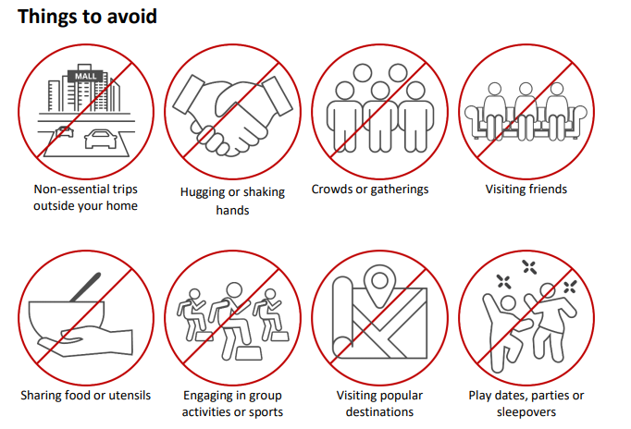

Read more about physical distancing here (Source: Public Health Ontario)

[If sharing electronically, keep link above. If providing printed copy, include handouts at end of information package – or reference site specific materials]

Respiratory Etiquette
It is important to help reduce the spread of illnesses by using proper respiratory etiquette. This means that instead of covering your mouth with your hands when coughing or sneezing, use your sleeve or a tissue. This reduces the number of germs on your hands, though it is still important to wash your hands after coughing and sneezing.

Respiratory etiquette must be practiced by all visitors during all visits on the residence property to reduce the risk of COVID-19 transmission.
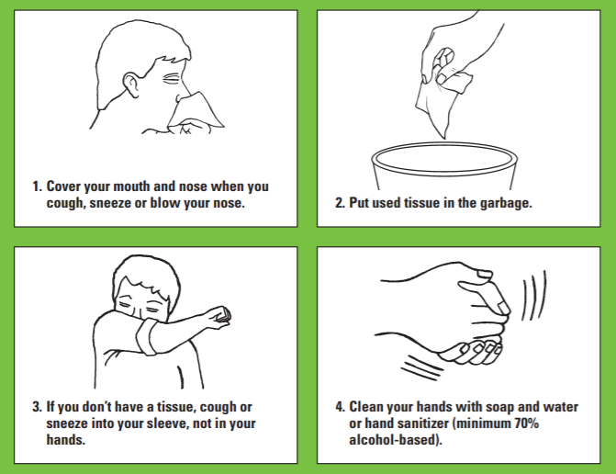

Following these steps is important:
- Cover your mouth and nose when you cough, sneeze or blow your nose.
- Put used tissue in the garbage.
- If you don’t have a tissue, cough or sneeze into your sleeve, not in your hand.
- Clean your hands with soap and water or hand sanitizer.

Read more about respiratory etiquette here (Source: Public Health Ontario)

Hand Hygiene
Hand hygiene is a general term referring to any action of hand cleaning and is a fundamental component of infection prevention and control. Hand hygiene relates to the removal of visible soil and removal or killing of transient microorganisms from the hands. Hand hygiene may be accomplished using an alcohol-based hand rub or soap and running water.
Touching your eyes, nose or mouth without cleaning your hands or sneezing or coughing into your hands may provide an opportunity for germs to get into your body. Keeping your hands clean through good hygiene practice is one of the most important steps to avoid getting sick and spreading germs to others.
Prior to beginning each visit with a resident, all visitors must perform hand hygiene. Additionally, any time your hands become soiled for any reason during the visit, you must perform hand hygiene. Wash or sanitize your hands at the end of the visit as well.
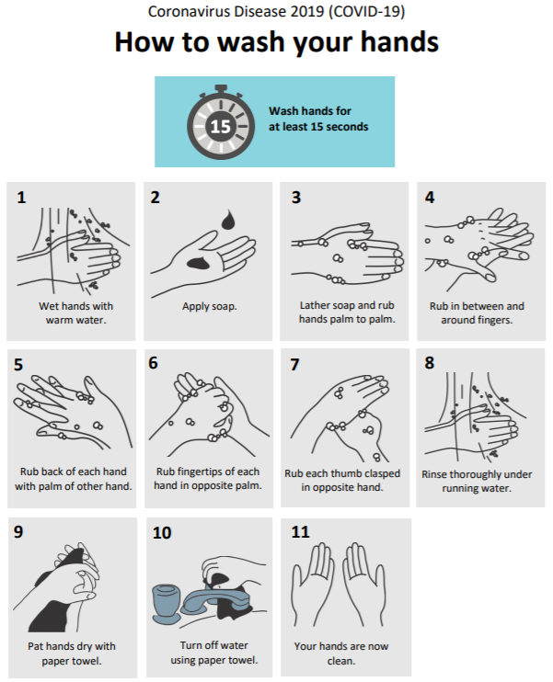
A. Handwashing
Handwashing with soap and running water, as opposed to using hand sanitizer, must be done when hands are visibly soiled. Hand hygiene with soap and water – done correctly – removes organisms.

Follow these steps for hand washing: (hand wash for at least 15 seconds)
- Wet hands with warm water.
- Apply soap.
- Lather soap and rub between fingers, back of hands, fingertips, under nails.
- Rinse thoroughly under running water.
- Dry hands well with paper towel.
- Turn taps off with paper towel.

Video: How to Hand Wash

B. Hand Sanitizing

Hand sanitizers are very useful when soap and water are not available. When your hands are not visibly dirty, then a 70-90% alcohol-based hand sanitizer/rub should be used. It has been shown to be more effective than washing with soap (even using an antimicrobial soap) and water when
hands are not visibly soiled.

Hand hygiene with alcohol-based hand sanitizer – correctly applied – kills organisms in seconds.

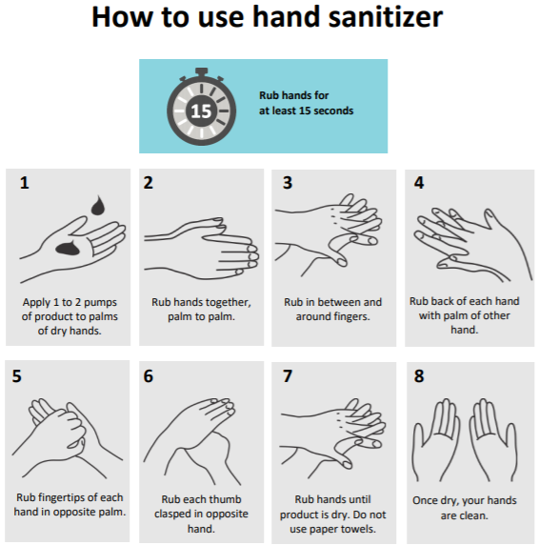
It is important when using an alcohol-based hand sanitizer to apply sufficient product such that it will remain in contact with the hands for a minimum of 15 seconds before the product becomes dry.

Follow these steps for sanitizing your hands: (rub hands for at least 15 seconds)
- Apply 1-2 pumps of product to palms of dry hands.
- Rub hands together, palm to palm, between and around fingers, back of hands, fingertips, under nails.
- Rub hands until product is dry. Do not use paper towels.
- Once dry, your hands are clean.

Read more about hand hygiene here (Source: Public Health Ontario)

Infection Prevention and Control (IPAC) Practices
Infection Prevention and Control (IPAC) refers to evidence-based practices and procedures that, when applied consistently in health care settings, can prevent or reduce the risk of transmission of microorganisms to residents, staff and visitors.

All visitors must follow the residence’s infection and prevention control protocols (IPAC), including proper use of face coverings/masks.

IPAC practices include:
- Hand hygiene program
- Screening and surveillance of infections
- Environmental cleaning procedures that reflect best infection control practices
- Use of personal protective equipment
- Outbreak detection and management
- Additional precautions specified to prevent the spread of infection
- Ongoing education on infection control

[Include information on site specific practices]

Read more about best practices for infection prevention and control here (Source: Public Health Ontario)

Proper Use of Personal Protective Equipment (PPE) Including Face Coverings/Masks
PPE is clothing or equipment worn for protection against hazards. Examples of PPE include gloves, gowns, facial protection and/or eye protection. Using, applying and removing personal protective equipment correctly is critical to reducing the risk of transmission of COVID-19.

All visitors must comply with the residence’s IPAC protocols, including wearing a face covering or mask as required, donning and doffing of PPE and following instructions on use provided by the residence.

General Visitors and Personal Care Service Providers:
- Visitors should use a face covering/mask if the visit is outdoors.
- If the visit is indoors, a surgical/procedure mask must be worn at all times.
- General visitors and personal care service providers are responsible for bringing their own face covering/mask. If visitors do not bring their own face coverings/masks (and the residence is not able to provide surgical/procedure masks if the visit is indoors), they cannot visit.

Essential Visitors:
- Support workers and caregivers are responsible for bringing their own PPE to comply with requirements for essential visitors as outlined in Directive #3. They are encouraged to work with the home to source the appropriate PPE to comply with these requirements, if needed.
Essential visitors who are:
- Providing direct care to a resident must use a surgical/procedure mask while in the home, including while visiting the resident that does not have COVID-19 in their room; and
- In contact with a resident who is suspected or confirmed with COVID-19 must wear appropriate PPE in accordance with Directive #5 and Directive #1.

Public Health Ontario:
Recommended Steps: Putting on Personal Protective Equipment (PPE)

Videos:
Putting on Full Personal Protective Equipment
Taking off Full Personal Protective Equipment

Putting on One-Piece Facial Protection

Taking off One-Piece Facial Protection

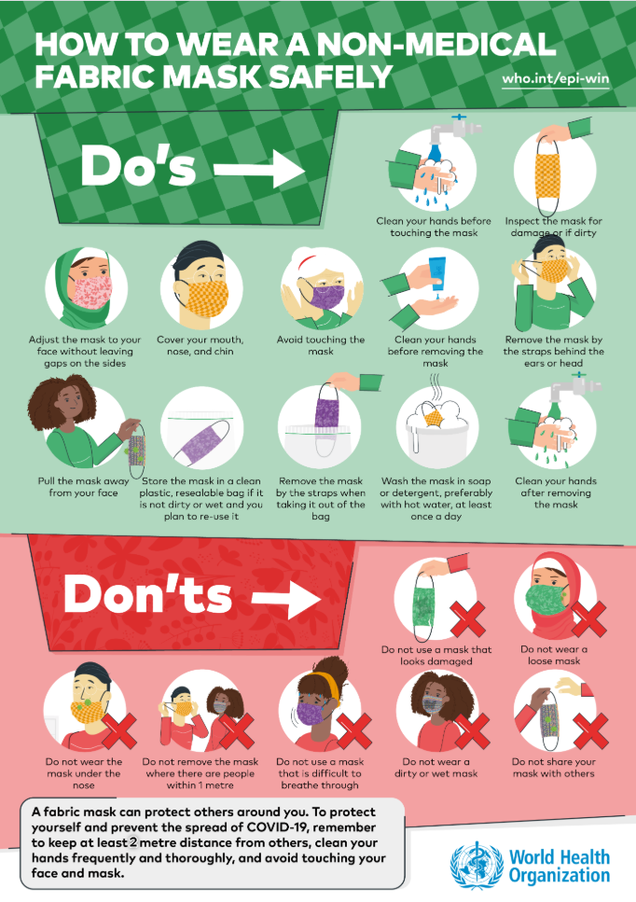
Source: World Health Organization (Non-Medical Fabric Mask) *Poster modified to 2 metres
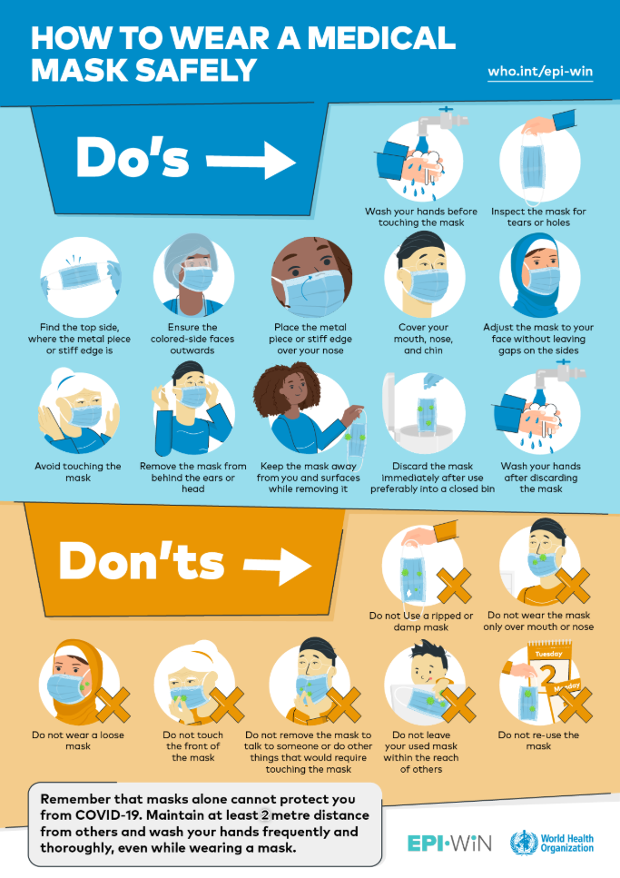
Source: World Health Organization (Medical Mask) *Poster modified to 2 metres
Appendix B – Sample Signage for Visitors
Visits with Your Loved Ones
During COVID-19
Expectations for Visits

Staying connected with others and the outdoors is important for everyone’s well-being.
To ensure the safety of residents and the whole retirement home community, all visitors must adhere to the following restrictions as per the Ontario Chief Medical Officer of Health (August 28, 2020) (CMOH, Directive #3). The home has begun a careful phased approach to the gradual resumption of resident visits that meets the health and safety needs of residents, staff, and visitors. Please refer to Ontario Government’s Reopening Retirement Homes guidance document for more information (September 8, 2020).

The following requirements must be met for visits to happen, they include:
- Visits can only be arranged when the retirement home is not in outbreak
- There will be a limit of ______ visitors per resident for outdoor visits
- Visits can only be arranged if there is adequate staffing to ensure safe visiting
- Visits can only be arranged if there is adequate testing in the event of a suspected outbreak
- Visits can only be arranged if there is enough staffing support to coordinate and assist residents to/from dedicated visit areas
- Visits can only be arranged if there is enough personal protective equipment (PPE) for staff and residents
- Visits can only be arranged with residents who are NOT on isolation
- Visits are to be scheduled/arranged and are time limited to ensure the health and safety needs of residents, staff and visitors is maintained
- Visitors must leave promptly at the end of the scheduled visit time to prevent overlap of scheduled visitors
- Visits can only be held in dedicated areas identified by the retirement home
- Visitors must pass the screening process every time they visit and must attest that they are not experiencing any typical/atypical symptoms of COVID-19
- Visitors must comply with the retirement home’s infection and prevention control protocols (IPAC) which includes:
  - Visitors must bring and wear a face covering/mask at all times
  - Visitors must wash/sanitize hands before and after each visit
  - Visitors must practice physical distancing (2 metres/6 feet apart)
  - No hugging, kissing, hand holding, or shaking hands; this increases the risk for transmission)
  - Visitors cannot visit more than 1 resident at a time

Guidelines for Outdoor Visits During COVID-19
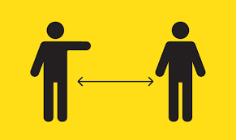
- Practice physical distancing
- Keep at least 2 metres or 6 feet apart

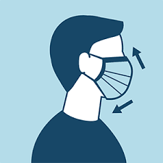

- Wearing a face covering/mask at all times is a MUST
- Don’t touch your face or others

- Wash or sanitize your hands before and after your visit

Appendix C - Sample Visiting Schedule
Name of Residence: |  |  | Date:
Visiting Hours: | From: | To:

Time | Resident Name  Suite # | Name of Visitor  Phone Number  Relationship to Resident | Name of Visitor  Phone Number  Relationship to Resident | Name of Visitor  Phone Number  Relationship to Resident
9:00 – 9:30 am
Clean and Disinfect
10:00-10:30 am
Clean and Disinfect
11:00 – 11:30 am
Clean and Disinfect
12:00-12:30 pm
Clean and Disinfect
1:00 – 1:30 pm
Clean and Disinfect
2:00 – 2:30 pm
Clean and Disinfect
3:00 – 3:30 pm
Clean and Disinfect
4:00 – 4:30 pm
Clean and Disinfect
5:00-5:30 pm
Clean and Disinfect
6:00 – 6:30 pm
Clean and Disinfect
7:00 – 7:30pm
Clean and Disinfect
8:00– 8:30 pm

Appendix D – Visitor Screening
SAMPLE COVID-19 ACTIVE SCREENING TOOL – VISITORS
This tool may be used for all visitors: Essential Visitors (Support Worker and Caregiver), General Visitors and Personal Care Service Providers.

Please have the visitor answer the following questions:
1. | Do you have any of the following new or worsening signs or symptoms?⁺
 | - New or worsening cough | Yes | No
 | - Shortness of breath | Yes | No
 | - Sore throat | Yes | No
 | - Runny nose, sneezing or nasal congestion  (in absence of underlying reasons for symptoms such as seasonal allergies and post nasal drip) | Yes | No
 | - Hoarse voice | Yes | No
 | - Difficulty swallowing | Yes | No
 | - New smell or taste disorder(s) | Yes | No
 | - Nausea/vomiting, diarrhea, abdominal pain | Yes | No
 | - Unexplained fatigue/malaise | Yes | No
 | - Chills | Yes | No
 | - Headache | Yes | No
 | - Croup | Yes | No
 | - Conjunctivitis | Yes | No
2. | Have you travelled or had close contact* with anyone who has travelled in the past 14 days? | Yes | No
3. | Do you have a fever? | Yes | No
4. | Have you had close contact* with anyone with respiratory illness or a confirmed or probable case of COVID-19? | Yes -  Go to Question 5 | No -  Skip question 5
5. | Did you wear the required and/or recommended PPE according to the type of duties you were performing (e.g. goggles, gloves, mask and gown or N95 with aerosol generating medical procedures (AGMPs)) when you had close contact with a suspected or confirmed case of COVID-19? | Yes | No
If individual passes screening questions 1 to 5:
 | Take temperature (fever is a temp of 37.8°C or greater) | Yes |  | No
 | The visitor attests to not be experiencing any of the typical and atypical symptoms. | Yes |  | No

*A close contact is defined as a person who provided care for the individual, including healthcare workers, family members or other caregivers, or who had other similar close physical contact (e.g. shaking hands, face-to-face contact within 2 metres and greater than 15 minutes, coughed on) or who lived with or otherwise had close prolonged contact (e.g. in a close environment such as a meeting room or hospital waiting room, in an aircraft sitting within two seats) with a probable or confirmed case of COVID-19 while the person was ill.

⁺ Refer to the Ministry of Health COVID-19 Reference Document for Symptoms (August 6, 2020) in adapting your screening tool and keeping it up to date with the latest signs/symptoms.

Screening Passed
- If the individual answers NO to all of the questions from #1-4 above, they do not have a fever, AND they have attested to not be experiencing any of the typical and atypical symptoms, they have passed screening and can enter the home OR

- If the individual answers NO to #1-3 and YES to #4 and #5, they do not have a fever, AND they have attested to not be experiencing any of the typical and atypical symptoms, they have passed screening and can enter the home.

The following steps should be taken by the home:
- The visitor should be told to self-monitor for symptoms
- Education on all required protocols will be provided
- The visitor should be reminded about required re-screening when they leave the home

The following steps must be taken by the essential visitor:
    - Use hand sanitizer upon entering
    - If providing direct care to a resident, use a surgical/procedure mask while in the home, including while visiting the resident that does not have COVID-19 in their room
    - Essential visitors who are in contact with a resident who is suspect or confirmed with COVID-19, must wear appropriate PPE in accordance with Directive #5 and Directive #1.

The following steps must be taken by the general visitor/personal care service provider:
    - Use hand sanitizer upon entering
    - If visiting a resident, only visit the one resident they are intending to visit and no other resident
    - Use a face covering/mask if the visit is outdoors. If the visit is indoors, a surgical/procedure mask is required. Visitors are responsible for bringing their own face covering/mask.
Any non-adherence to these rules could be the basis for discontinuation of visits.

Screening Failed
- If the individual answers YES to any question from #1-3, or does not attest to not having typical or atypical symptoms, they have failed screening and cannot enter the home, AND/OR

- If the individual answers YES to #4 and NO to #5 or does not attest to not having typical or atypical symptoms, they have failed screening and cannot enter the home.

The following steps should be taken by the home:
- If applicable, the visitor should be told to contact a primary care provider, local public health unit or Telehealth to discuss their symptoms and/or exposure and seek testing.

The following steps must be taken by the visitor:
- If applicable, the visitor should go home to self-isolate immediately

Please refer to May 6, 2020 Ministry of Health COVID-19 Screening Tool for Long-Term Care Homes and Retirement Homes.

SAMPLE COVID-19 SAFETY REVIEW – VISITORS

Prior to visiting any resident for the first time after this policy is released, and at least once every month thereafter:

For Caregivers/General Visitors/Personal Care Service Providers:

The caregiver, general visitor/personal care service providers verbally attests that they have:
1. | Read/Re-Read the following documents:
 | - The home’s visitor policy | Yes | No
 | - Public Health Ontario’s document entitled Recommended Steps: Putting on Personal Protective Equipment (PPE) | Yes | No
2. | Watched/Re-watched the following Public Health Ontario videos:
 | - Putting on Full Personal Protective Equipment | Yes | No
 | - Taking off Full Personal Protective Equipment | Yes | No
 | - How to Hand Wash | Yes | No

Visitor Screening Tracker
Legend: Passed: P-A = NO to all questions #1-#4 + no fever + attestation OR P-B = NO to #1-3 & YES to #4 & #5 + no fever + attestation
Failed: F-A = YES to any question #1-#3, no attestation AND/OR F-B = YES to #4 & NO to #5, no attestation

Date | Screening Time (Time In) | Visitor Name Printed/Reason for Visit | Screening result  P-A or P-B;  F-A and/or F-B | Temp | Time Out
6/28/20 | 8:45am | Jane Doe, Visiting Tom Doe | P-A | 36.5 | 9:30am

Appendix E – MSAA Visitor Signage
All signs can be downloaded and printed here:
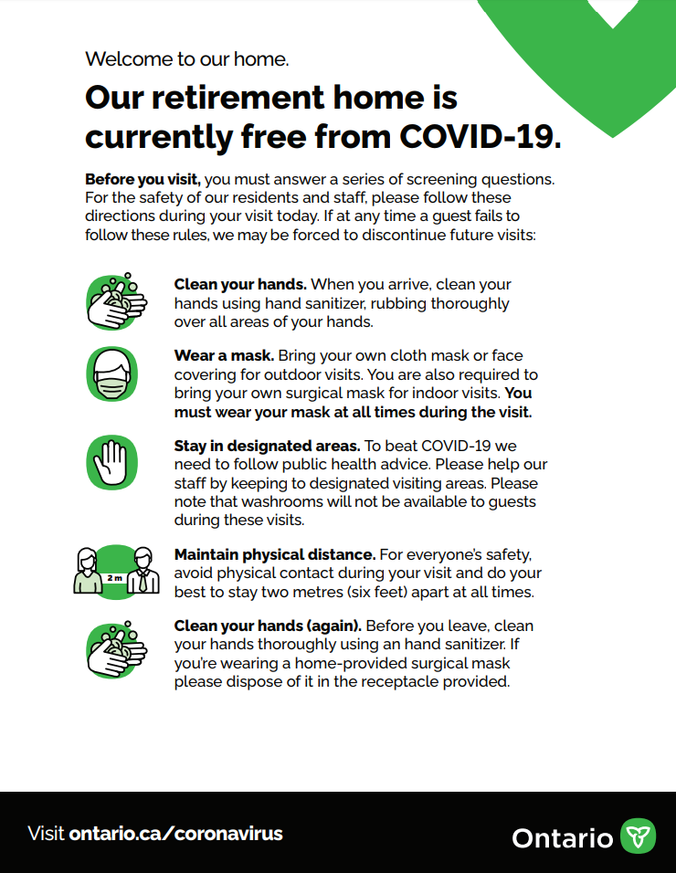
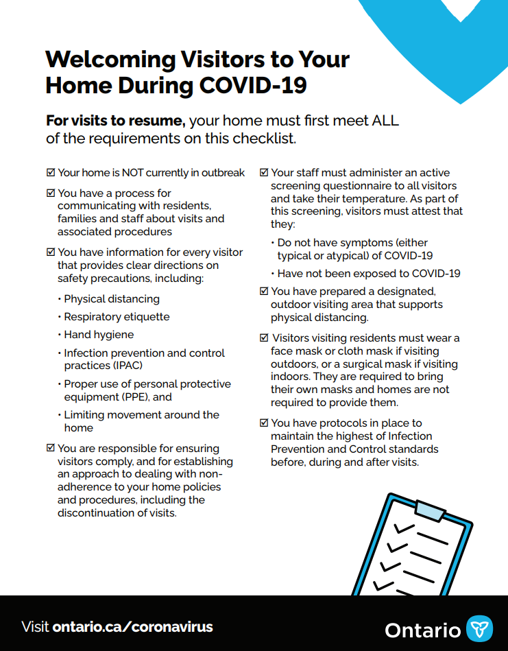
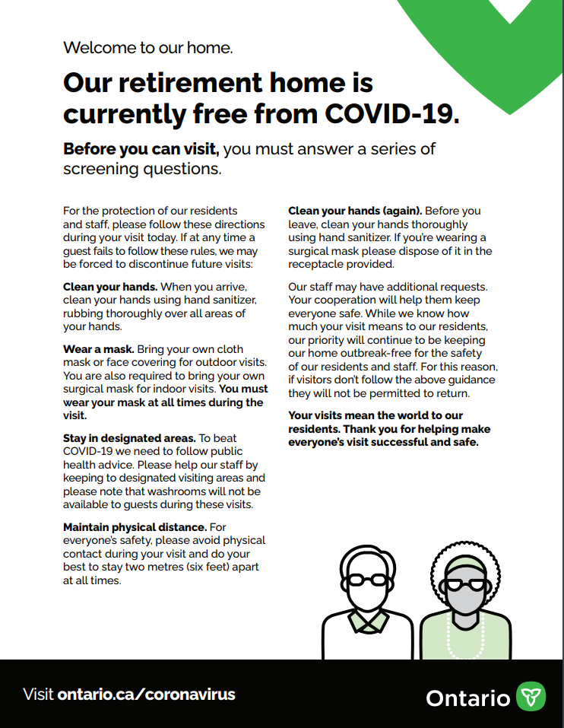
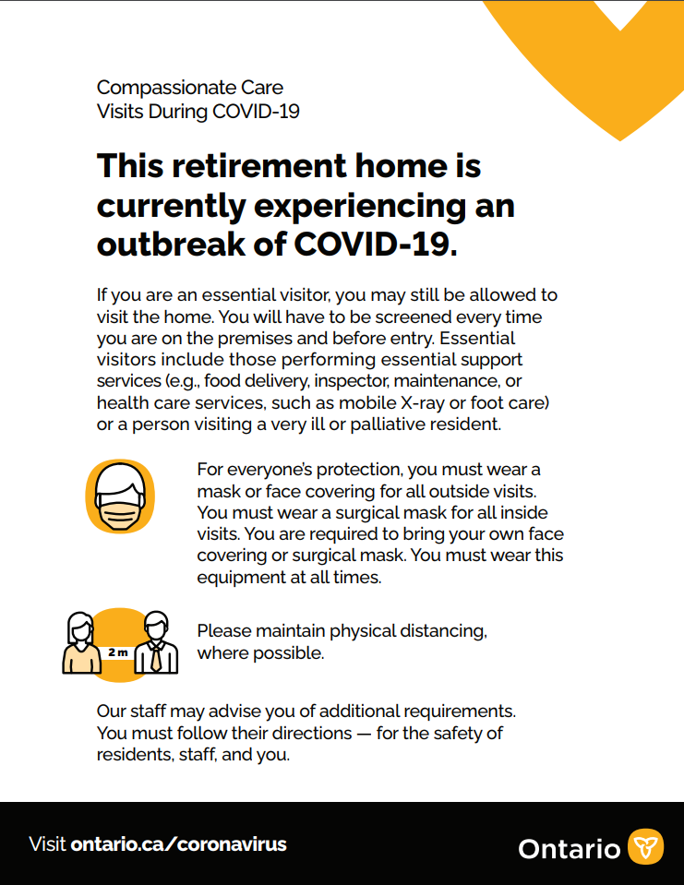
https://www.orcaretirement.com/wp-content/uploads/RetirementHomes-Visitors_Posters-EN-FINAL-july172020-FINAL-ua.pdf
